**NO SQL DATABASE FOR IMPLEMENTING E-COMMERCE APPLICATION**

*Submitted by*

***Rohit Pandey***

***Reg. No. 21352046***

***M.C.A (3rd Semester)***

*Project phase – First review on 28/09/2022*

**CSCA513 - Mini Project**

*Under the guidance of*

**Dr. Pothula Sujatha**

**Associate Professor**



**DEPARTMENT OF COMPUTER SCIENCE**

**SCHOOL OF ENGINEERING AND TECHNOLOGY**

**PONDICHERRY UNIVERSITY**

**PUDUCHERRY- 605014**

**SEPTEMBER 2022**

**Tech Stacks:** JavaScript, MongoDB, Express.js, React.js & Node.js

This project is an E-commerce web application (IndiaMart) which lists various products & allows user to purchase products after logging in.

It will have a payment gateway integrated.

**Usability:**

Desktop interface

Windows 7/8/10/11 & and upcoming versions

**Block Diagram:**

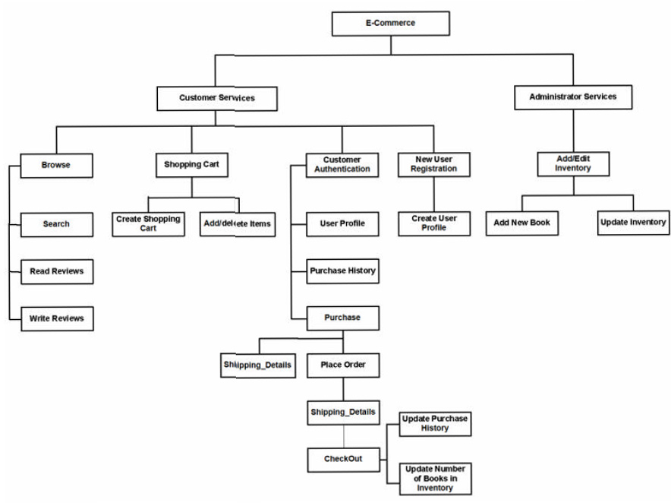

___________________

Mentor In-Charge

**Dr. Pothula Sujatha**

Associate Professor

Department of Computer Science,

School of Engineering & Technology,

Pondicherry University